Charge Jack Mod:

The charge jack mod enables your transmitter to charge the Aeroace by use of an external AC to DC universal adapter. By charging your Aeroace this way, you eliminate using the AA batteries for charging, saving the batteries for flight. This greatly extends the life of the batteries. Typically the AA’s will only last about 20 charges in the transmitter.

The modification requires a jack with a disconnect switch built in. This disconnect switch is used to bypass the internal AA battery pack in the transmitter. There is a variety to choose from on the market. The one used in this modification was from an old calculator, but Radio Shack has a variety to choose from such as the Size K Coaxial DC Power Jack w/Switch P/N: 274-1565. It was chosen because it matched up with a number of universal adapters on the market today.

Start by opening the case:

Start by unscrewing the transmitter antenna and remove. Next flip the transmitter over, and remove the four visible screws.
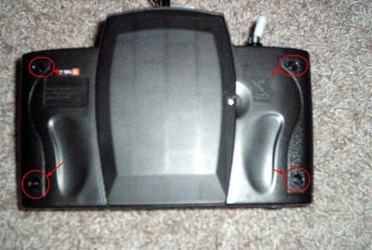
Remove the battery cover. There are three additional screws inside the cover where the batteries go. Remove them.
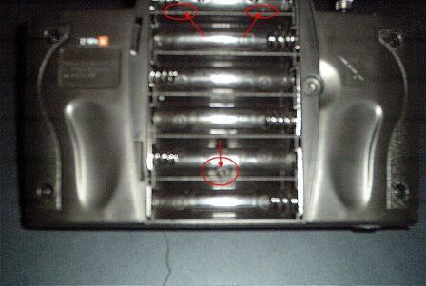
Slit the sticker where the antenna goes in. This will allow you to open the case. Remember that the case will open only so far, because of the charge cable!

You need to cut a hole in the case for the charge jack. The best place for this is the lower left hand corner of the case and test fit. You may have to also trim part of the cover.
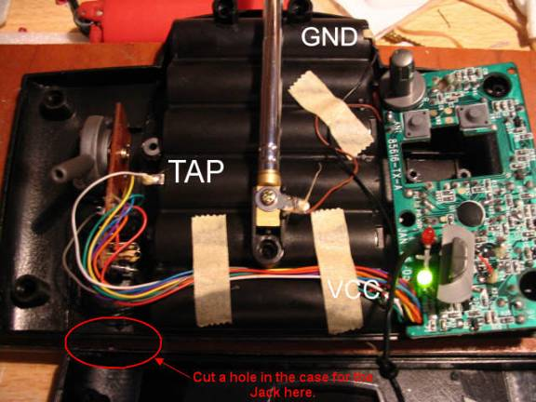
The jack can be secured with hot glue:
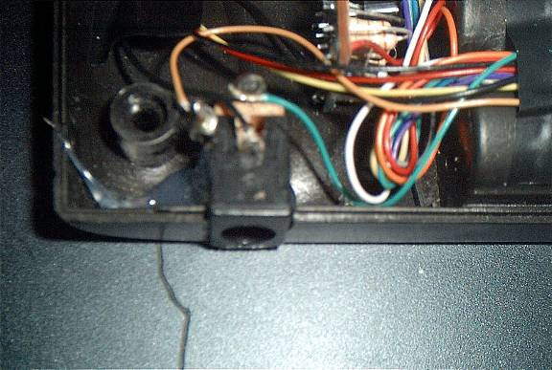

Unsolder the Ground (-) negative wire from the battery pack compartment.
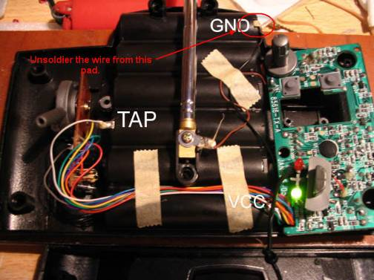
This wire needs to be spliced and extended to the new charge jack.
The wire should be soldiered to one of the outer ground ring terminals on the jack as shown:
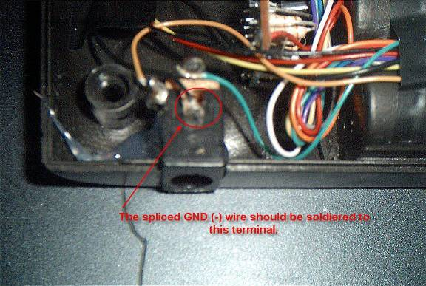

A new wire should be connected to the other outer ground ring terminal.
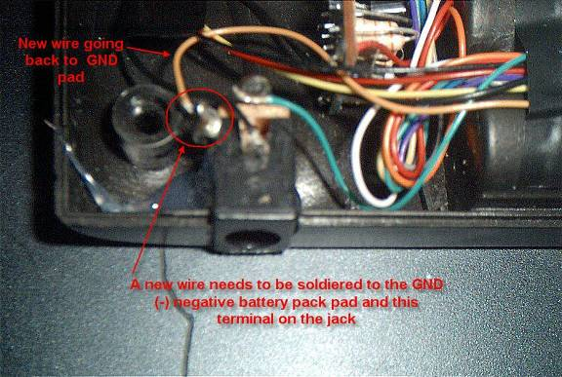

This wire should be routed back to the GND battery pack connection and soldiered in place of the removed one:
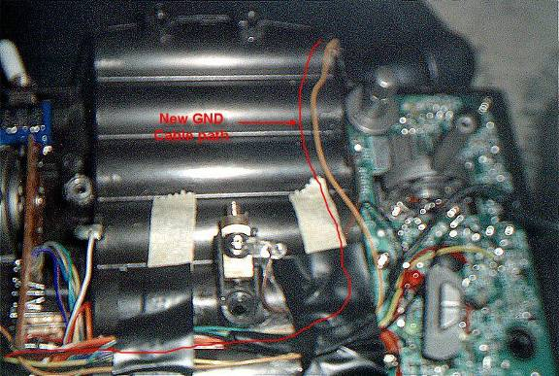

A VCC (+) cable needs to be connected to the center pin terminal of the jack as shown:
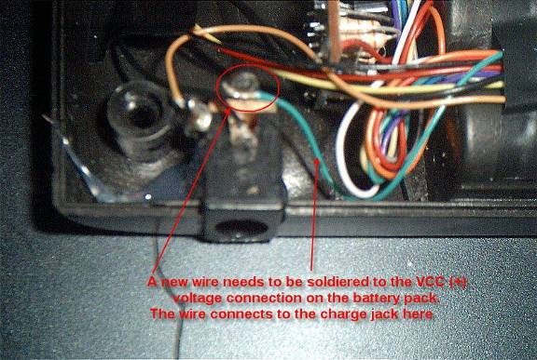

The other end of this wire should be soldiered on top of the existing VCC(+) wire as shown:
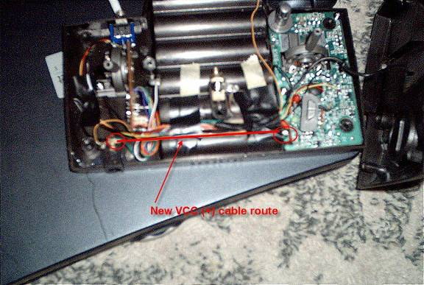
Note: The wiring between the charge jack and the battery compartment assumes the center pin of the jack will be positive (+) polarity, and the outer contact (-) negative polarity.

Once this is done, your mod is complete. Put the case back together, and reinstall the batteries. Plug the transmitter charge cable into the Aeroace. If done correctly the transmitter green charge light should come on. Remove the charge cable from the Aeroace.

Next obtain a universal AC to DC adapter. Make sure that the VCC (+) connection is set to the center pin and that the output voltage is set for 9 volts!

Plug the adapter output cable into the transmitter, and then plug the adapter into the AC outlet. Plug the transmitter charge cable into the Aeroace. If done correctly the transmitter green charge light should come on. Congratulations, your modification has been tested and complete.
A note about Universal Adapters:

There are a wide variety of adapters available today. Besides using an AC to DC adapter, there is also a DC to DC car lighter adapter on the market. Using this type of adapter allows you to use your charger as a field charger as well. Show below is a picture of the Vector Universal DC to DC adapter for your reference:
